Enrollments / Case punchlist

Enrollment Reports

1. ~~Relocate “Summary” table above other lines. So the vertical order is Group Title, Summary header and table, Period, Product, Method(s), Case Agents, and then (later) Products table  
   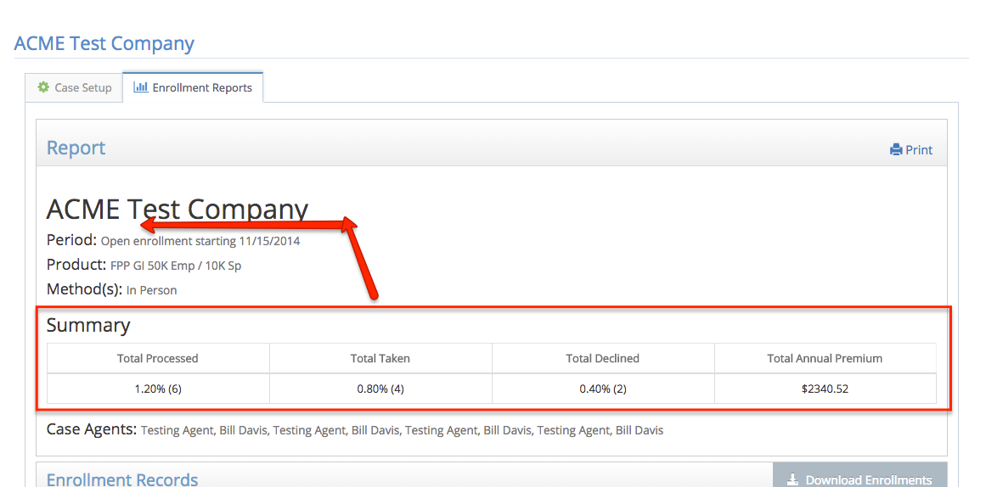~~
2. In “Total Processed” cell, add total number of records to parenthesis, as in  
   1.2% (6 of 500)
   1. The “…of 500)” is redundant on the adjacent Total Take and Total Declined cells; let’s just display this in the “Total Processed”
3. ~~Add a new leading column, “Date/Time” with the date/time stamp (e.g., 01/27/15 15:41) – I think this is Signature Date in the file~~

~~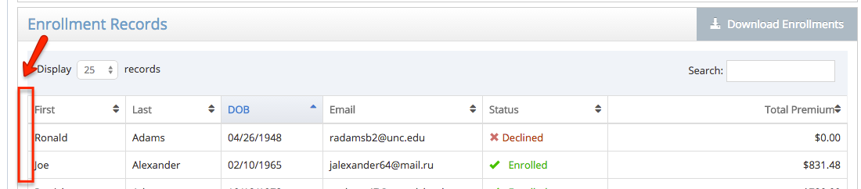~~

1. Download file
   1. Rename “Signature Date” header in file to be “Timestamp” and make it 1st column
   2. Make status second column
   3. Add fields
      1. Agent Code
      2. Agent Name
      3. Beneficiaries (all 4 fields)
2. BUG: Printing a report multiple time adds duplicate summary tables:  
   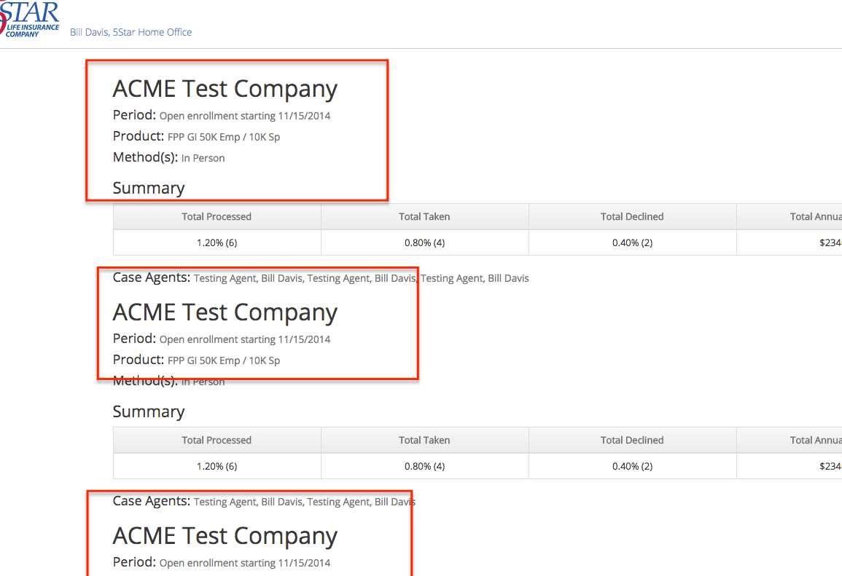
3. Can we easily just open the print target in a separate window? (or is that bad form?) Otherwise after printing the user is left on a static page with no navigation.
4. Allow Horizontal scroll on tables at <768px
5. Otherwise, would like mobile-friendly tables (perhaps for 2.5 release if there’s not a ready vehicle to do this):
   1. Breakpoints   
      I: <1024  
      II: <768w  
      III: <600w  
      IV: <560w  
      V: <480w
   2. Enrollment Records (on Enrollment Report)
      1. Default: Time, First, Last, DOB, email, status, premium
      2. At I: Time, First, Last, DOB, ~~email~~, status, premium
      3. At II: ~~Time,~~ First, Last, ~~DOB, email,~~ status, premium
      4. At V: ~~Time,~~ First, Last, ~~DOB, email, status~~, premium
   3. Case Census (on Case Setup)
      1. Default: First, Last, DOB, email, status
      2. At II: First, Last, DOB, ~~email,~~ status
      3. At IV: First, Last, ~~DOB, email,~~ status
      4. At V: First, Last~~, DOB, email, status~~
   4. Enrollment Table (on Enroll from Case)
      1. Default: button, Status, First, Last, DOB, email
      2. At III: button, Status, First, Last, DOB~~, email~~
      3. At IV: button, Status, ~~First,~~ Last, DOB~~, email~~
      4. At V we’ll rely on horiz scroll
6. Total Premium cell on enrollment records is $0 or else empty after overwriting one of the records? See email exchange with sample downloads Friday 1/30 circa 5:07pm
7. Turns out, subsequent applications are always additive, never overwriting. So let’s change our report so that:
   1. Multiple records are listed expressly in the UI (not a ‘merged’ record)
   2. Download records likewise show all enrollment records (i.e., so may have multiple rows with same SSN).

Case Setup

1. Tried to delete existing active case with an enrollment record (“123 Testco”), and got an error “There was a problem removing this case”. I assume this is because the case had active enrollments. Is there some other situation in which we would display this message? If not, let’s either hide the delete button such a case or else use this message:  
    *Cannot delete a case with posted enrollments. Instead mark the case as ‘inactive’.*  
   whichever is your UI preference.
   1. I’m not sure either of those options is a complete answer; hiding the button is leaving the user under-informed, and offering the button is misleading. I suspect the best thing is making button inactive with a tool-tip giving the above message.
2. BUG (minor, could be 2.5): I created a new GI product, added it to a Case and made the case active. Then before any enrollments on the case I deleted the GI product, which left the case in an Active state with no product defined. Should make such case inactive just as if removed product from UI.
3. (minor, could be 2.5) Is it easy to make a the open enrollment start date field not have to type in slashes for the date entry (as we don’t have to for the Annual Periods fields or even birthdate fields elsewhere)?
4. Census record edits don’t appear to be working – clicking Save button seems like no-op.
5. Would like to have “nuclear option” for Home Office to delete a case, even if we have enrollment records. So, effectively this means *only for home office users* to activate the delete key with a clear double-ask on a modal-dialog confirmation, that will delete the case and all associated Census and Enrollment records.   
   Confirmation message1: *This case has X enrollments that have been processed. Deleting the case will permanently remove all associated enrollment and census records; they will not be retrievable.  
   Are you sure you want to permanently remove all enrollment and census records? [yes, permanently delete] [no, don’t delete]* (default=no)  
     
   Confirm message2: About to permanently remove all enrollment and census records for XYZ Case. Are you *really* sure?  
   [yes, really delete] [no!, don’t delete] (default=no)
6. Change multi-pick on product to a single-pick (for now)

Home-Office

1. Setup GI product
   1. If used (selected for) any case, list in new section (same style header as “Guarantee Issue Criteria” and “When GI and criteria met”) at bottom (above Delete button) “Used in Cases”
   2. After “Save” button click, return to Manage Products screen
   3. Simplify and reverse logic (in UI) on SOH-type questions, so just drop the radio choice and swap the labels on the icons (grey-x = ‘ignored’, blue-check = ‘required’)  
      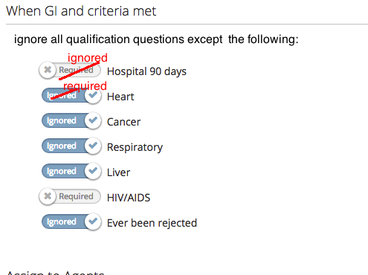
2. ~~Header menu should always be Home, Agents, Products, Cases, Logout  
   - these pages appear to be incorrect~~
   1. ~~edituser (Agents > click a name)~~
   2. ~~All the Manage Cases pages (manage-cases, manage-case,~~
3. BUG: Made another user a Home Office user, but she does not have access to any existing cases:  
   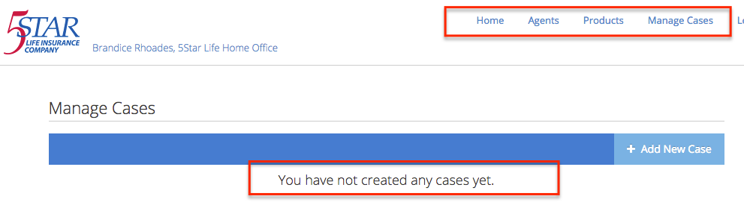
4. “Home Office” header label missing in “Manage Cases” screens, and menu pill not selected when in Manage Cases screens:  
     
     
   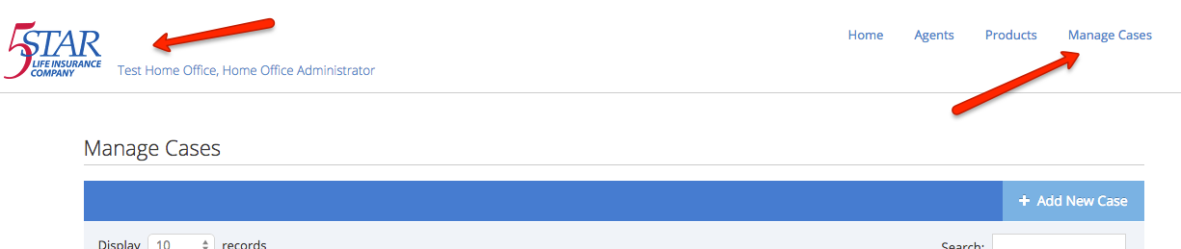

Enrollment Ad Hoc

1. ~~BUG: “Product to Enroll” drop down should include all products to which I have visibility, a la the same as in Case Setup~~
2. BUG: went through whole ad-hoc FPP-TI enrollment and got error at end “Sorry, an error occurred communicating with the server.” – thinking this is perhaps related to turning Docusign API back on?
3. BUG: If I “Decline” an ad-hoc (doesn’t make much sense, but…) and click Next I get an error . Same/Related issue for bug #2 above?
4. BUG: attempting an “Ad-hoc, in person” enrollment (any product) crashes with browser message:   
   *The browser (or proxy) sent a request that this server could not understand*
5. BUG: It seems the “valid states” menu isn’t adjusting based on the product selected. (e.g,. Indiana is active for FPP-CI but inactive for FPP-TI)

Enrollment from Case

1. Enrollment main screen (6 buttons)
   1. Make a tool tip on “Enroll… via phone” that says “You are not authorized for call-center enrollment”
      1. While this will be universal for now, I expect to have it be a simple checkbox on the edituser screen (i.e., once we turn on call-center workflow, Home Office will designate who is authorized to enroll via a validated call center)
   2. Make a tool-tip on “Enroll…via email” that says “this feature coming soon!”
2. Enrolling ad-hoc not in census
   1. let’s revert to just check SSN and not DOB, too. More likely someone’s miskeyed a DOB (and we miss matching their SSN) than having a duplicate or miskeyed SSN.
      1. BTW, when I keyed in DOB as mmddyyyy the model just sat and spun on “Checking census for matches…” – I have to cancel out. But when I keyed in mm/dd/yyyy it found the record right away.  
         So, eventhough we’re eliminating the DOB let’s ensure what happens if we have bad data or a key not found.
   2. ~~The new record should have “married” as false by default (it’s coming in as true)~~
3. ~~BUG: Enrolling GI (e.g., “ACME Test Company”)… if I ask a GI knock out question,~~ **~~but on a child~~**~~, then the child is simply eliminated unless the child is listed in the rules (which in this case they weren’t). Your error message shows:~~*~~A "yes" response to this question prohibits this person from obtaining the selected $10,000 of coverage. You may proceed, however, by reducing your coverage to the guaranteed coverage amount of $-Infinity.~~*
4. BUG: ~~Enrolling GI… if I “remove this applicant” when I hit a GI knock-out, then the resulting SOH headers/table is misaligned:   
   Before:  
   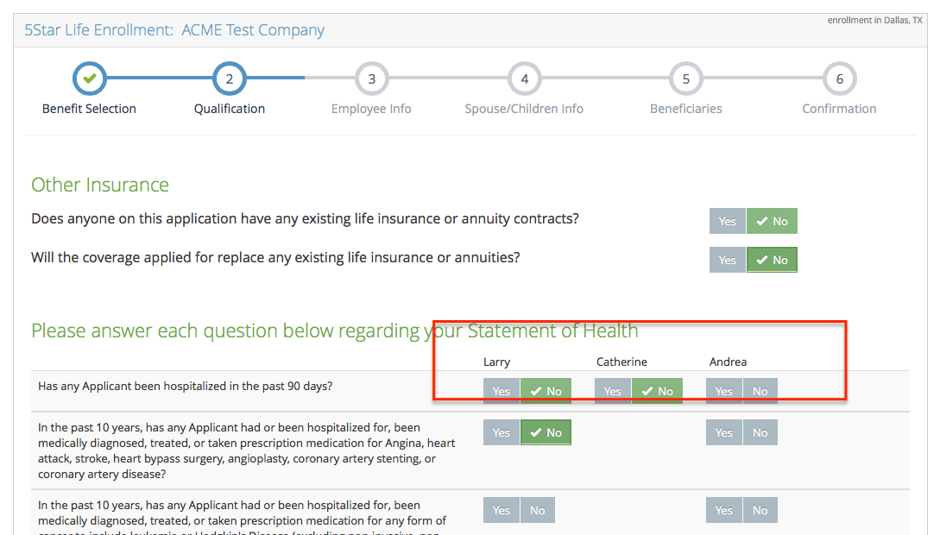  
     
   After eliminating EE:  
   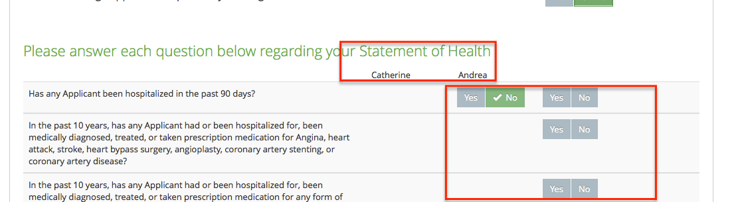~~
   1. Now we’re blanking the whole column (fine), but would prefer to omit the ‘blank’ – at least if we enter step 2 from step1 (with there’s a “no benefit” selected); but I appreciate that it’s all the same layout/javascript on the wizard.  
      So, perhaps this is something for 2.5 when we may have to tackle > 4 children on enrollment.
5. Post-signature/Enroll Next Applicant … can we eliminate the “flash” to the Enroll-from-Case screen and instead just go from the application-completed message page straight to the census page?
6. Re-Enroll (ok to push to 2.5)  
   Can we also pull in the “as enrolled” (i.e., that ‘merged record’) along with census… so we don’t have a “show rates” but show the selection table already as previously enrolled (but don’t repopulate the SOH questions – those have to be answered uniquely per compliance).
7. Enrolling GI (minor, OK to push to 2.5)… if I “remove this applicant” because of a “yes” GI knock-out so that effectively everyone is no benefit, we should return to step 1 in a “declined = true” state. As it is, they will merely continue forward with a $0 application, but we’d like to avoid that (especially in a self-serve mode). See related item #1 below under “Enrollment in general”.
8. BUG: Enrolling from Case initially displays case name, but after first enrollment and clicking “Enroll next applicant”, the case name no longer appears in header:  
   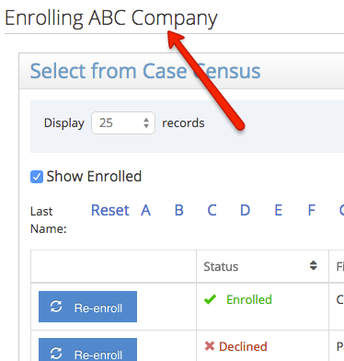 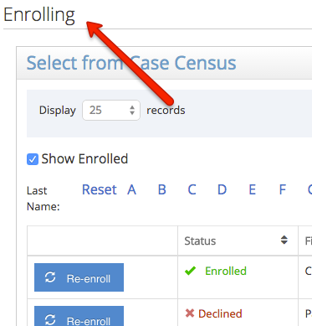
9. BUG: we seem to be not setting the Married boolean from the case record… not married census records are starting with blank spouse:  
   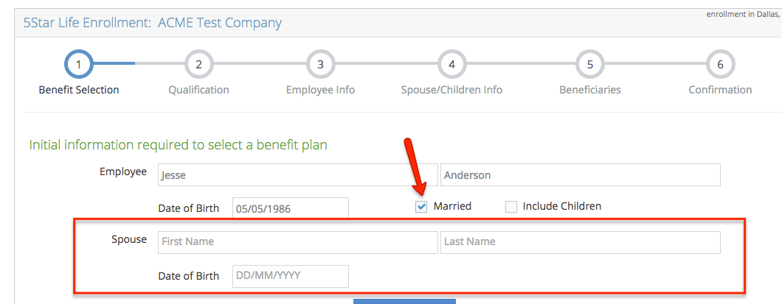
10. Enrolling a GI product with criteria on Children (see test product “[FPP GI 50EE / 10Sp](http://demo.5starenroll.com:9876/manage-products/15)”), I have multiple criteria set for children depending on age, and I’m trying to enroll for a record with a child in each age criteria spec’d on the GI product def. A “yes” SOH for the >10yr old should knock down to 10K (which has to adjust both), but initially the other (<10 yr old) shouldn’t even have those SOH’s to answer since she’s in GI ‘range’.   
    The answer is goofy either way:  
    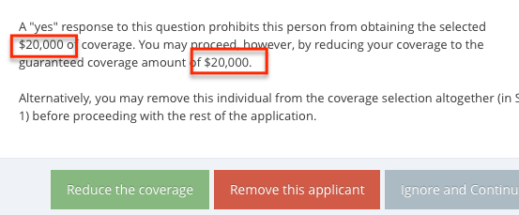
11. Re-enroll
    1. Change “Re-enroll” label to “Add-on”
    2. When re-enrolling, can we display an error message if an applicant requests a benefit larger than the reminder given total earlier enrollments? E.g., Joe applied for $100K FPP and $75K spouse, and today re-enrolls for $75K FPP for himself and $125K for spouse; want a dialog to alert:  
       “Given a previous application this enrollment period of $100,000 coverage, Joe can apply for a maximum of $50,000 additional coverage.  
       Given a previous application this enrollment period of $75,000 coverage, Mary can apply for a maximum of $75,000 additional coverage.”  
         
       I.e., we won’t bother trying to auto-adjust, etc., but we do want to add to the error check on the “next” button to confirm coverage limits, with error message   
       “Coverage requested exceeds allowable limit across all applications, you must adjust before advancing.”
    3. If this is a re-enroll, then we need to omit the “I decline” option  
       (i.e., there can be no “decline” record after a submitted/signed enrollment record)

Enrollment in general

1. SOH / step 2
   1. (push to 2.5 if not simple) when generally rejecting a “Yes” SOH question which results in a popup of “…disqualifies … proceed after removing that individual…”, can we also offer the same red & grey buttons as with GI, “Remove this applicant” and “Ignore and continue”   
      (caveat: if that’s the last applicant and you remove in Step 2, then have to return to step one with the state of “Declined” and “no benefits” selected)
2. Step1: when adding a spouse or children, default the last name to be same as EE last name.
3. This isn’t “enrollment”, but didn’t know where else to document it…  
   We should adjust the copyright date in the footer to 2015.

Group CI enrollment

1. BUG: Step1: Height/Weight highlighting inconsistently; let’s not single out any one item, but merely highlight both in tandem (regardless whether only one value falls outside a range), so not this:  
   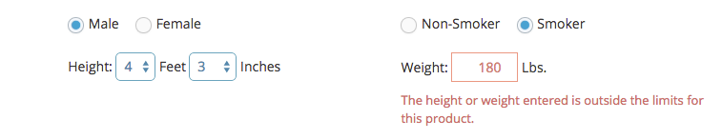but more like this:  
   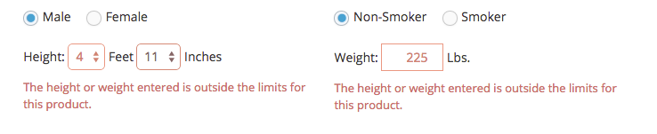although perhaps just a single error message under “height”, but all fields (feet, inches and lbs) display as ‘error’ (so, pragmatically, error message for ‘height’ stays same and error message for weight exists but just a blank?)
2. BUG: Step1: if I enter an out of range *weight*, and get an error message that removes the applicant from the GBB table, and then edit weight back in range the applicant row remains eliminated. I can ‘force’ it back into the table by manipulating the height to get it to reset.
3. TBD: talk through “GI logic” on using Group CI as base product.  
   Remember: when reducing or removing EE, then Spouse and CH can still get max levels (not limited by 50% rule)